BROCKHAM CHORAL

Come and Sing
Rossini’s ‘Stabat Mater’
on Sunday 31st January 2027
Conductor – David Swinson
From 12.00 to 4.30 pm

Bring your own lunch and a mug
Coffee, tea and cake provided
at
St John’s School, Goodwyns Rd, Dorking. RH4 2LR
Cost: £15 per person
Scores will be available if required

To book your place go to ticketsource
https://www.ticketsource.com/brockham-choral/t-zoxpvnz
More information: www.brockhamchoral.org

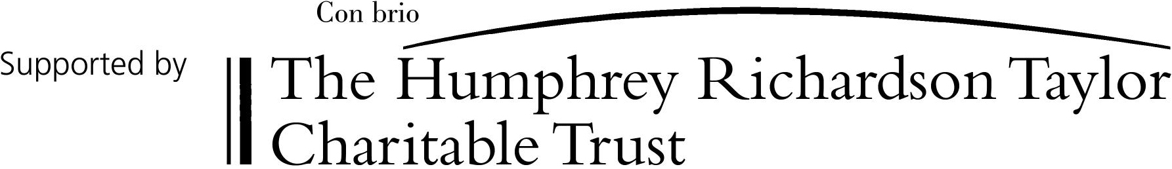

Registered charity No: 284300

